**Please be sure to setup your system before moving onto Week 2 or Week 3.**

Directions adapted from software tools for Software Carpentry workshops, please see license details below.

## Setup

To participate in this course,  you will need access to the software described below. In addition, you will need an up-to-date web browser.

We maintain a list of common issues that occur during installation as a reference for instructors that may be useful on the [Configuration Problems and Solutions wiki page](https://github.com/swcarpentry/workshop-template/wiki/Configuration-Problems-and-Solutions/).

### The Bash Shell

Bash is a commonly-used shell that gives you the power to do simple tasks more quickly.

#### Windows

[Video Tutorial](https://www.youtube.com/watch?v=339AEqk9c-8)

1. Download the Git for Windows [installer](https://git-for-windows.github.io/).
2. Run the installer and follow the steps bellow:
   1. Click on "Next".
   2. 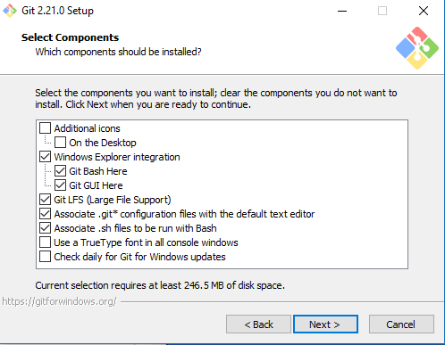
   3. Click on "Next". **Unless you would like to change the install destination, then click "Browse".**
   4. 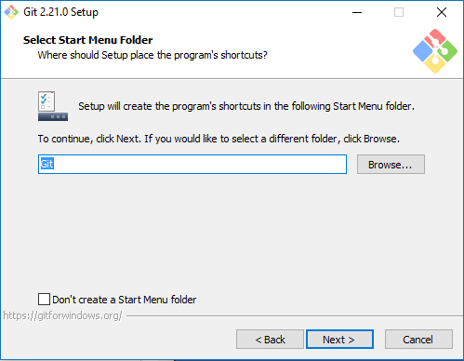
   5. Select your desired editor. Note: This is entirely up to you, pictured on the right is the choice of Atom, a free editor with built-in support for Git and Github. After you have chosen, click "Next".
   6. 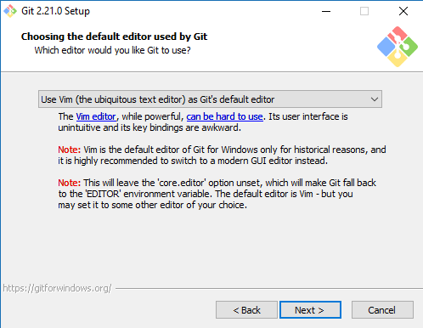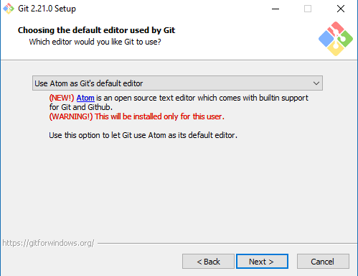
   7. **Keep "Use Git and optional Unix tools from the Windows Command Prompt" selected and click on "Next".**If you forgot to do this, programs that you need for the workshop will not work properly. If this happens, rerun the installer and select the appropriate option.
   8. 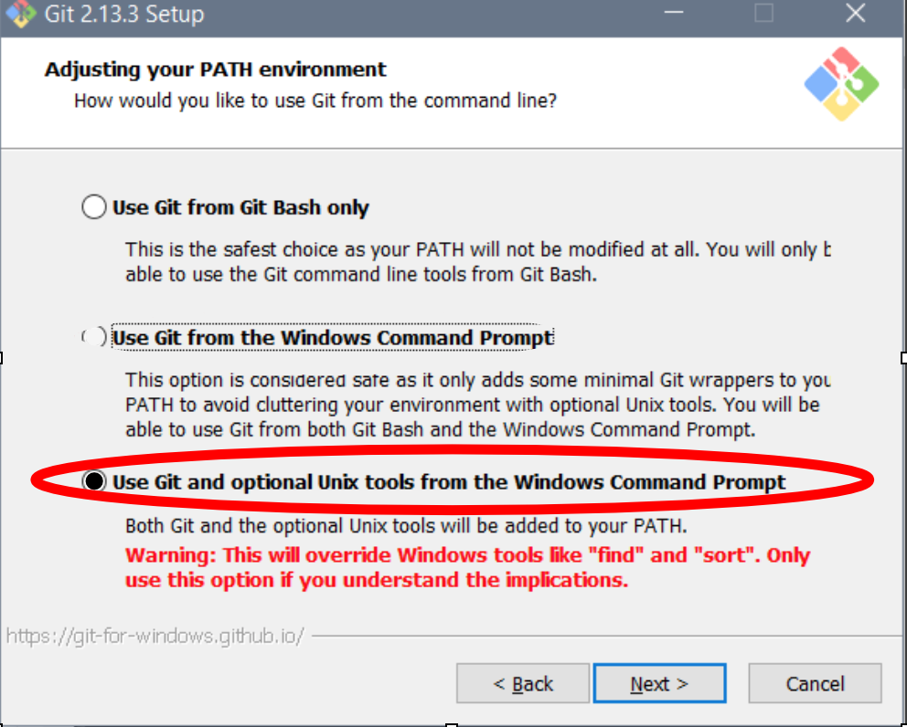
   9. 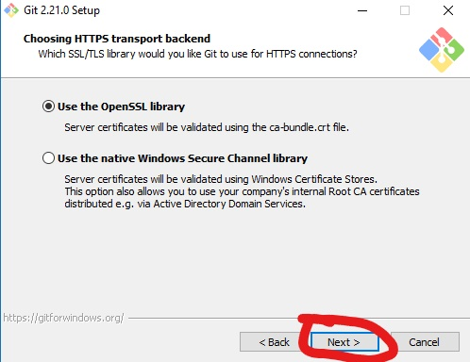
   10. **Keep "Checkout Windows-style, commit Unix-style line endings" selected and click on "Next".**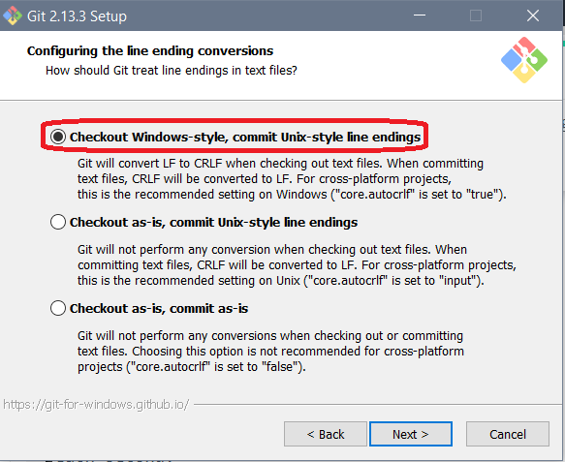
   11. **Keep "Use Windows' default console window" selected and click on "Next".**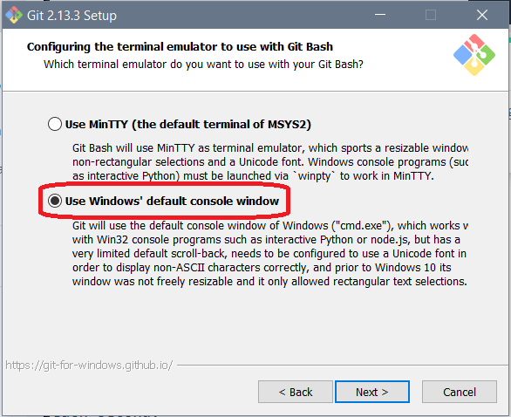
   12. 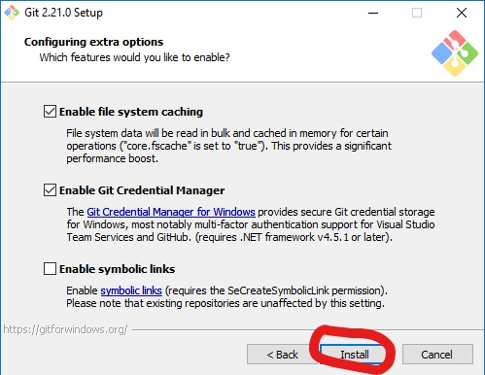
   13. Click on "Finish".
3. If your "HOME" environment variable is not set (or if you don't know what this is):
   1. Open command prompt (Open Start Menu, then type cmd and press [Enter])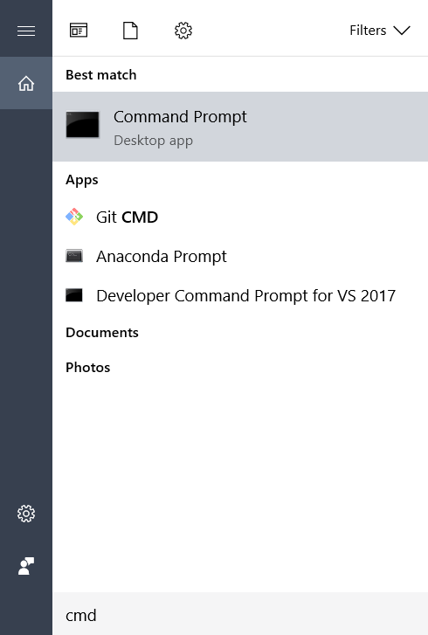
   2. Type the following line into the command prompt window exactly as shown:setx HOME "%USERPROFILE%"
   3. Press [Enter], you should see SUCCESS: Specified value was saved.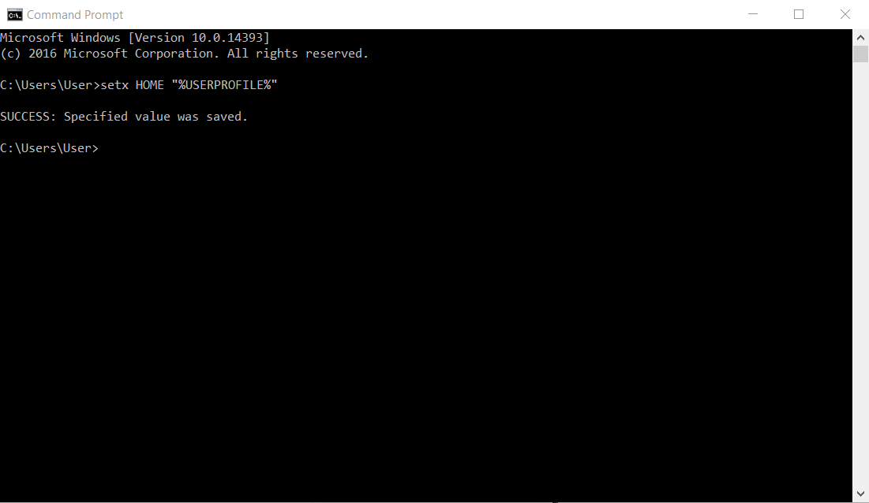
   4. Quit command prompt by typing exit then pressing [Enter]

This will provide you with both Git and Bash in the Git Bash program.

#### Mac OS X

The default shell in all versions of Mac OS X is Bash, so no need to install anything. You access Bash from the Terminal (found in /Applications/Utilities). See the Git installation [video tutorial](https://www.youtube.com/watch?v=9LQhwETCdwY) for an example on how to open the Terminal. You may want to keep Terminal in your dock for this workshop.

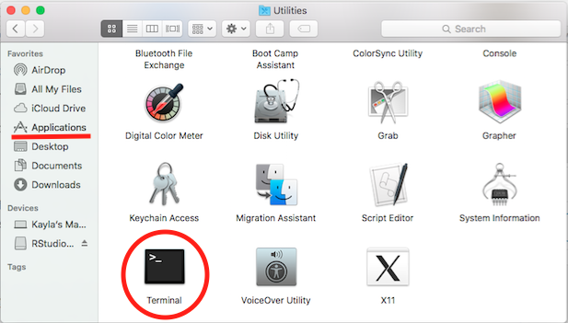

#### Linux

The default shell is usually Bash, but if your machine is set up differently you can run it by opening a terminal and typing bash. There is no need to install anything.

### Python

[Python](http://python.org/) is a popular language for research computing, and great for general-purpose programming as well. Installing all of its research packages individually can be a bit difficult, so we recommend [Anaconda](https://www.anaconda.com/), an all-in-one installer.

Regardless of how you choose to install it, **please make sure you install Python version 3.x** (e.g., 3.4 is fine).

We will teach Python using the Jupyter notebook, a programming environment that runs in a web browser. For this to work you will need a reasonably up-to-date browser. The current versions of the Chrome, Safari and Firefox browsers are all [supported](http://ipython.org/ipython-doc/2/install/install.html" \l "browser-compatibility) (some older browsers, including Internet Explorer version 9 and below, are not).

#### Windows

[Video Tutorial](https://www.youtube.com/watch?v=xxQ0mzZ8UvA)

1. Open [http://continuum.io/downloads](https://www.anaconda.com/download/#windows) with your web browser.
2. Download the Python 3 installer for Windows. 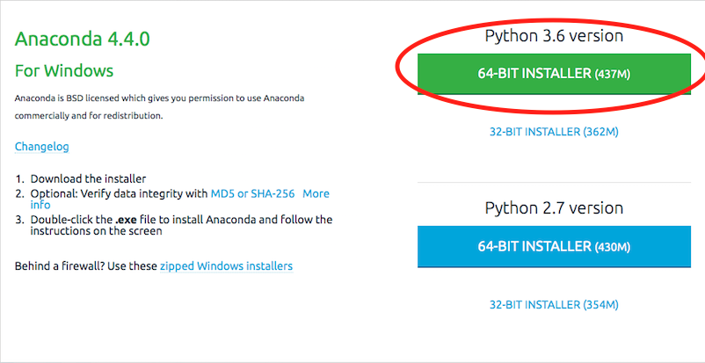
3. Install Python 3 using all of the defaults for installation, except make sure to check **Make Anaconda the default Python ("Register Anaconda as my default Python 3.x")**.

To run Python (later in the course), you need to open an "Anaconda Prompt" (from Start Menu)

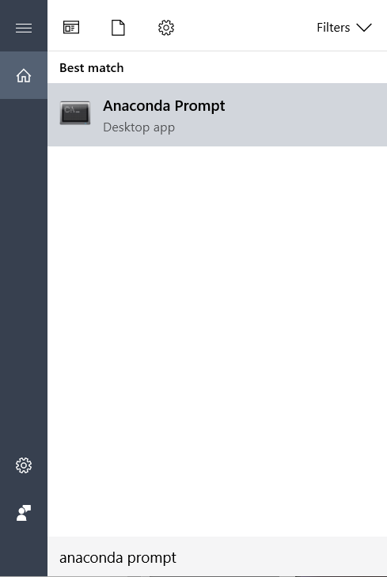

and type  
>python

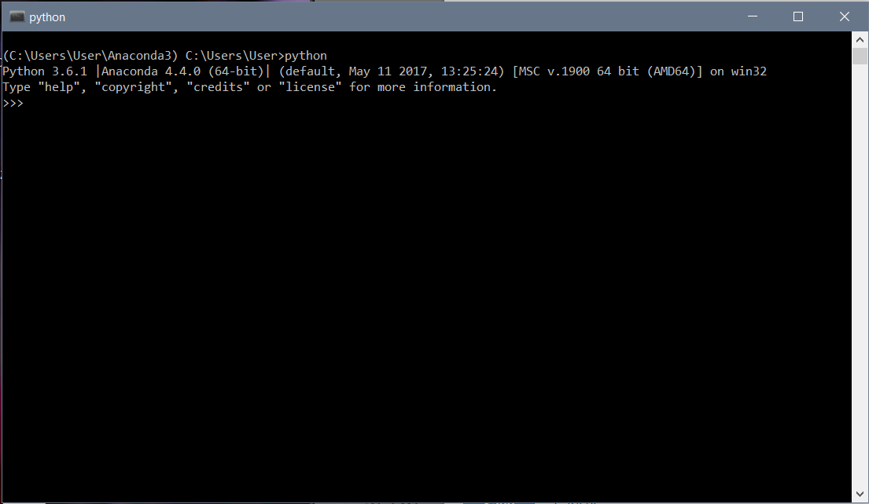

To run Jupyter (later in the course), you need to open an "Anaconda Prompt" (from Start Menu) and type  
>jupyter notebook

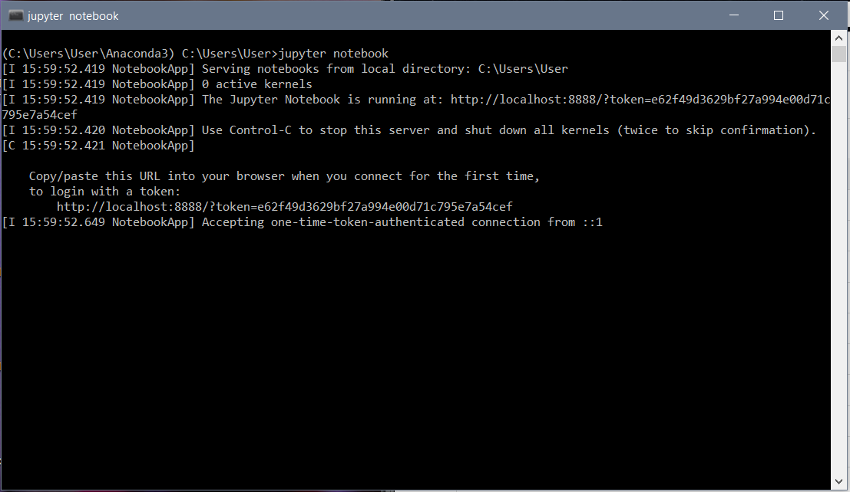

#### macOS

[Video Tutorial](https://www.youtube.com/watch?v=TcSAln46u9U)

1. Open [http://continuum.io/downloads](https://www.anaconda.com/download/#macos) with your web browser.
2. Download the Python 3 installer for OS X.
3. 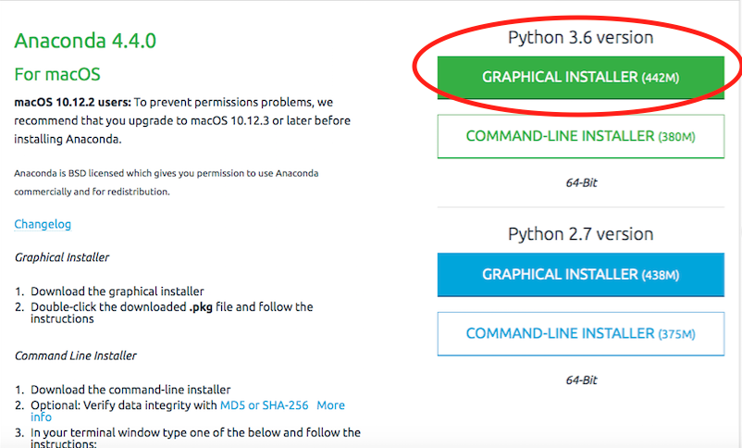
4. Install Python 3 using all of the defaults for installation.

#### Linux

1. Open [http://continuum.io/downloads](https://www.anaconda.com/download/#linux) with your web browser.
2. Download the Python 3 installer for Linux.  
   (Installation requires using the shell. If you aren't comfortable doing the installation yourself, stop here and request help in the discussions.) 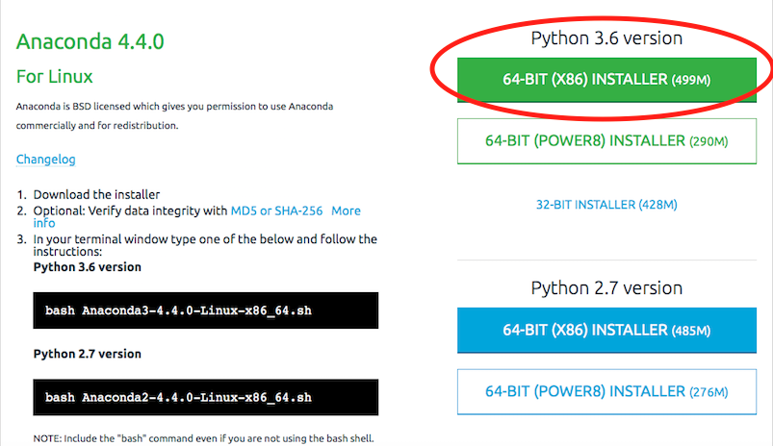
3. Open a terminal window.
4. Type

bash Anaconda3-

and then press tab. The name of the file you just downloaded should appear. If it does not, navigate to the folder where you downloaded the file, for example with:

cd Downloads

Then, try again.

1. Press [Enter]. You will follow the text-only prompts. To move through the text, press the [space] key. Type yes and press [Enter] to approve the license. Press [Enter] to approve the default location for the files. Type yes and press [Enter] to prepend Anaconda to your PATH (this makes the Anaconda distribution the default Python).
2. Close the terminal window.

Installation instructions licensed under [Creative Commons Attribution license](https://creativecommons.org/licenses/by/4.0/) were adapted from [Software Carpentry](https://github.com/swcarpentry/workshop-template)